LAPORAN TUGAS PRAKTIKUM 9

PEMROGRAMAN BERORIENTASI OBJEK



Prabowo Gosal 52015031

STMIK KHARISMA Makassar

Program studi INFORMATIKA 2015

/*

PraktikumPBO1 project

Source Code activity_main.xml

<?xml version=**"1.0"** encoding=**"utf-8"**?>

<RelativeLayout xmlns:android=**"http://schemas.android.com/apk/res/android"**

xmlns:tools=**"http://schemas.android.com/tools"**

android:layout_width=**"match_parent"**

android:layout_height=**"match_parent"**

tools:context=**"com.example.lenovo.praktikumpbo1.MainActivity"**>

**//membuat id text**

**//menyesuaikan ukuran lebar dengan induknya**

**//mengatur tinggi layout sebesar 70dp**

<EditText

android:id=**"@+id/result_id"**

android:layout_width=**"match_parent"**

android:layout_height=**"70dp"** />

**//membuat tombol**

**//membuat id tombol**

**//membuat lebar tombol**

**//membuat tinggi**

**//mengatur posisi tombol berada pada bagian bawah text**

**//membuat text pada tombol**

<Button

android:id=**"@+id/Btn1_id"**

android:layout_width=**"90dp"**

android:layout_height=**"80dp"**

android:layout_below=**"@id/result_id"**

android:onClick=**"btn1Clicked"**

android:text=**"1"** />

**//membuat posisi tombol berada pada samping kanan dari tombol 1**

<Button

android:id=**"@+id/Btn2_id"**

android:layout_width=**"90dp"**

android:layout_height=**"80dp"**

android:layout_below=**"@id/result_id"**

android:layout_toRightOf=**"@id/Btn1_id"**

android:onClick=**"btn2Clicked"**

android:text=**"2"** />

<Button

android:id=**"@+id/Btn3_id"**

android:layout_width=**"90dp"**

android:layout_height=**"80dp"**

android:layout_below=**"@id/result_id"**

android:layout_toRightOf=**"@id/Btn2_id"**

android:onClick=**"btn3Clicked"**

android:text=**"3"** />

<Button

android:id=**"@+id/Btnclear_id"**

android:layout_width=**"110dp"**

android:layout_height=**"80dp"**

android:layout_below=**"@id/result_id"**

android:layout_toRightOf=**"@id/Btn9_id"**

android:onClick=**"btnclearClicked"**

android:text=**"clear"** />

<Button

android:id=**"@+id/Btn4_id"**

android:layout_width=**"90dp"**

android:layout_height=**"80dp"**

android:layout_below=**"@id/Btn1_id"**

android:onClick=**"btn4Clicked"**

android:text=**"4"** />

<Button

android:id=**"@+id/Btn5_id"**

android:layout_width=**"90dp"**

android:layout_height=**"80dp"**

android:layout_below=**"@id/Btn2_id"**

android:layout_toRightOf=**"@id/Btn4_id"**

android:onClick=**"btn5Clicked"**

android:text=**"5"** />

<Button

android:id=**"@+id/Btn6_id"**

android:layout_width=**"90dp"**

android:layout_height=**"80dp"**

android:layout_below=**"@id/Btn3_id"**

android:layout_toRightOf=**"@id/Btn5_id"**

android:onClick=**"btn6Clicked"**

android:text=**"6"** />

<Button

android:id=**"@+id/Btnplus_id"**

android:layout_width=**"110dp"**

android:layout_height=**"80dp"**

android:layout_below=**"@id/Btnclear_id"**

android:layout_toRightOf=**"@id/Btn6_id"**

android:onClick=**"btnplusClicked"**

android:text=**"+"** />

<Button

android:id=**"@+id/Btn7_id"**

android:layout_width=**"90dp"**

android:layout_height=**"80dp"**

android:layout_below=**"@id/Btn4_id"**

android:onClick=**"btn7Clicked"**

android:text=**"7"** />

<Button

android:id=**"@+id/Btn8_id"**

android:layout_width=**"90dp"**

android:layout_height=**"80dp"**

android:layout_below=**"@id/Btn5_id"**

android:layout_toRightOf=**"@id/Btn7_id"**

android:onClick=**"btn8Clicked"**

android:text=**"8"** />

<Button

android:id=**"@+id/Btn9_id"**

android:layout_width=**"90dp"**

android:layout_height=**"80dp"**

android:layout_below=**"@id/Btn6_id"**

android:layout_toRightOf=**"@id/Btn8_id"**

android:onClick=**"btn9Clicked"**

android:text=**"9"** />

<Button

android:id=**"@+id/Btnminus_id"**

android:layout_width=**"110dp"**

android:layout_height=**"80dp"**

android:layout_below=**"@id/Btnplus_id"**

android:layout_toRightOf=**"@id/Btn3_id"**

android:onClick=**"btnminusClicked"**

android:text=**"-"** />

<Button

android:id=**"@+id/Btnequal_id"**

android:layout_width=**"126dp"**

android:layout_height=**"80dp"**

android:layout_below=**"@id/Btn7_id"**

android:onClick=**"btnequalClicked"**

android:text=**"="** />

<Button

android:id=**"@+id/Btndivide_id"**

android:layout_width=**"126.5dp"**

android:layout_height=**"80dp"**

android:layout_below=**"@id/Btn8_id"**

android:layout_toRightOf=**"@id/Btnequal_id"**

android:onClick=**"btndivideClicked"**

android:text=**"/"** />

<Button

android:id=**"@+id/Btnmulti_id"**

android:layout_width=**"126dp"**

android:layout_height=**"80dp"**

android:layout_below=**"@id/Btnminus_id"**

android:layout_toRightOf=**"@id/Btndivide_id"**

android:onClick=**"btnmultiClicked"**

android:text=**"*"** />

</RelativeLayout>

Source Code Main_Activity.java

package com**.**example**.**lenovo**.**praktikumpbo1**;**

**import** android**.**os**.**Bundle**;**

**import** android**.**support**.**v7**.**app**.**AppCompatActivity**;**

**import** android**.**view**.**View**;**

**import** android**.**widget**.**EditText**;**

public class MainActivity **extends** AppCompatActivity **{**

// Mendeklarasikan Variabel

public String str **=**""**;**

Character op **=** 'q'**;**

float i**,**num**,**numtemp**;**

EditText showResult**;**

@Override

public void onCreate**(**Bundle savedInstanceState**)** **{**

**super.**onCreate**(**savedInstanceState**);**

setContentView**(**R**.**layout**.**activity_main**);**

showResult **=** **(**EditText**)**findViewById**(**R**.**id**.**result_id**);**

**}**

public void btn1Clicked**(**View v**){** //Memasukkan nilai 1 ke dalam variabel j

insert**(**1**);**

**}**

public void btn2Clicked**(**View v**){** //Memasukkan nilai 2 ke dalam variabel j

insert**(**2**);**

**}**

public void btn3Clicked**(**View v**){** //Memasukkan nilai 3 ke dalam variabel j

insert**(**3**);**

**}**

public void btn4Clicked**(**View v**){** //Memasukkan nilai 4 ke dalam variabel j

insert**(**4**);**

**}**

public void btn5Clicked**(**View v**){** //Memasukkan nilai 5 ke dalam variabel j

insert**(**5**);**

**}**

public void btn6Clicked**(**View v**){** //Memasukkan nilai 6 ke dalam variabel j

insert**(**6**);**

**}**

public void btn7Clicked**(**View v**){** //Memasukkan nilai 7 ke dalam variabel j

insert**(**7**);**

**}**

public void btn8Clicked**(**View v**){** //Memasukkan nilai 8 ke dalam variabel j

insert**(**8**);**

**}**

public void btn9Clicked**(**View v**){** //Memasukkan nilai 9 ke dalam variabel j

insert**(**9**);**

**}**

public void btnplusClicked**(**View v**){** //membuat op bernilai +

perform**();**

op **=** '+'**;**

**}**

public void btnminusClicked**(**View v**){** //membuat op bernilai -

perform**();**

op **=** '-'**;**

**}**

public void btndivideClicked**(**View v**){** //membuat op bernilai /

perform**();**

op **=** '/'**;**

**}**

public void btnmultiClicked**(**View v**){** //membuat op bernilai *

perform**();**

op **=** '*'**;**

**}**

public void btnequalClicked**(**View v**){** //tombol = di tekan maka dihitung

calculate**();**

**}**

public void btnclearClicked**(**View v**){**

reset**();**

**}** //Mereset smuax menjadi null

private void reset**()** **{**

// TODO Auto-generated method stub

str **=**""**;**

op **=**'q'**;**

num **=** 0**;**

numtemp **=** 0**;**

showResult**.**setText**(**""**);**

**}**

private void insert**(**int j**)** **{** //metode untuk menampilkan nilai pada layar

// TODO Auto-generated method stub

str **=** str**+**Integer**.**toString**(**j**);** //mengisi var str dengan conver ke string dari var j

num **=** Integer**.**valueOf**(**str**).**intValue**();** //mengkonvert var str ke integer

showResult**.**setText**(**str**);** //menampilkan isi str

**}**

private void perform**()** **{**

// TODO Auto-generated method stub

str **=** ""**;**

calculateNoShow**();**

numtemp **=** num**;**

**}**

private void calculate**()** **{**

// TODO Auto-generated method stub

**if(**op **==** '+'**)** //jika op = + maka lakukan operasi penambahan

num **=** numtemp**+**num**;**

**else** **if(**op **==** '-'**)** //jika op = - maka lakukan operasi pengurangan

num **=** numtemp**-**num**;**

**else** **if(**op **==** '/'**)** //jika op = / maka lakukan operasi pembagian

num **=** numtemp**/**num**;**

**else** **if(**op **==** '*'**)** //jika op = * maka lakukan operasi perkalian

num **=** numtemp**\***num**;**

showResult**.**setText**(**""**+**num**);** //menampilkan hasil

**}**

private void calculateNoShow**()** **{** //metode untuk menghitung tanpa menampilkan dilayar

// TODO Auto-generated method stub

**if(**op **==** '+'**)**

num **=** numtemp**+**num**;**

**else** **if(**op **==** '-'**)**

num **=** numtemp**-**num**;**

**else** **if(**op **==** '/'**)**

num **=** numtemp**/**num**;**

**else** **if(**op **==** '*'**)**

num **=** numtemp**\***num**;**

**}**

**}**

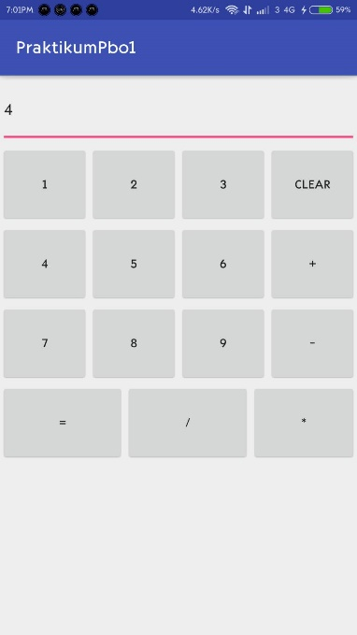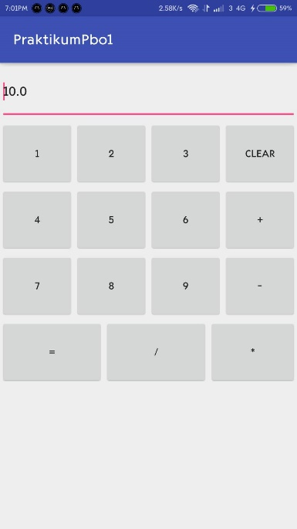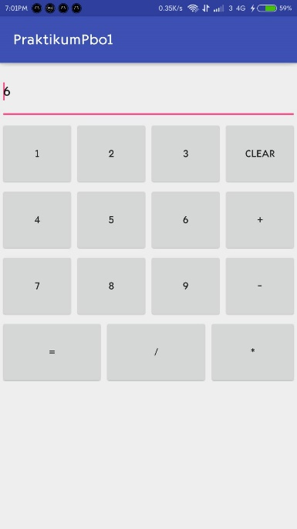Hasil uji Coba

4 + 6 = 10